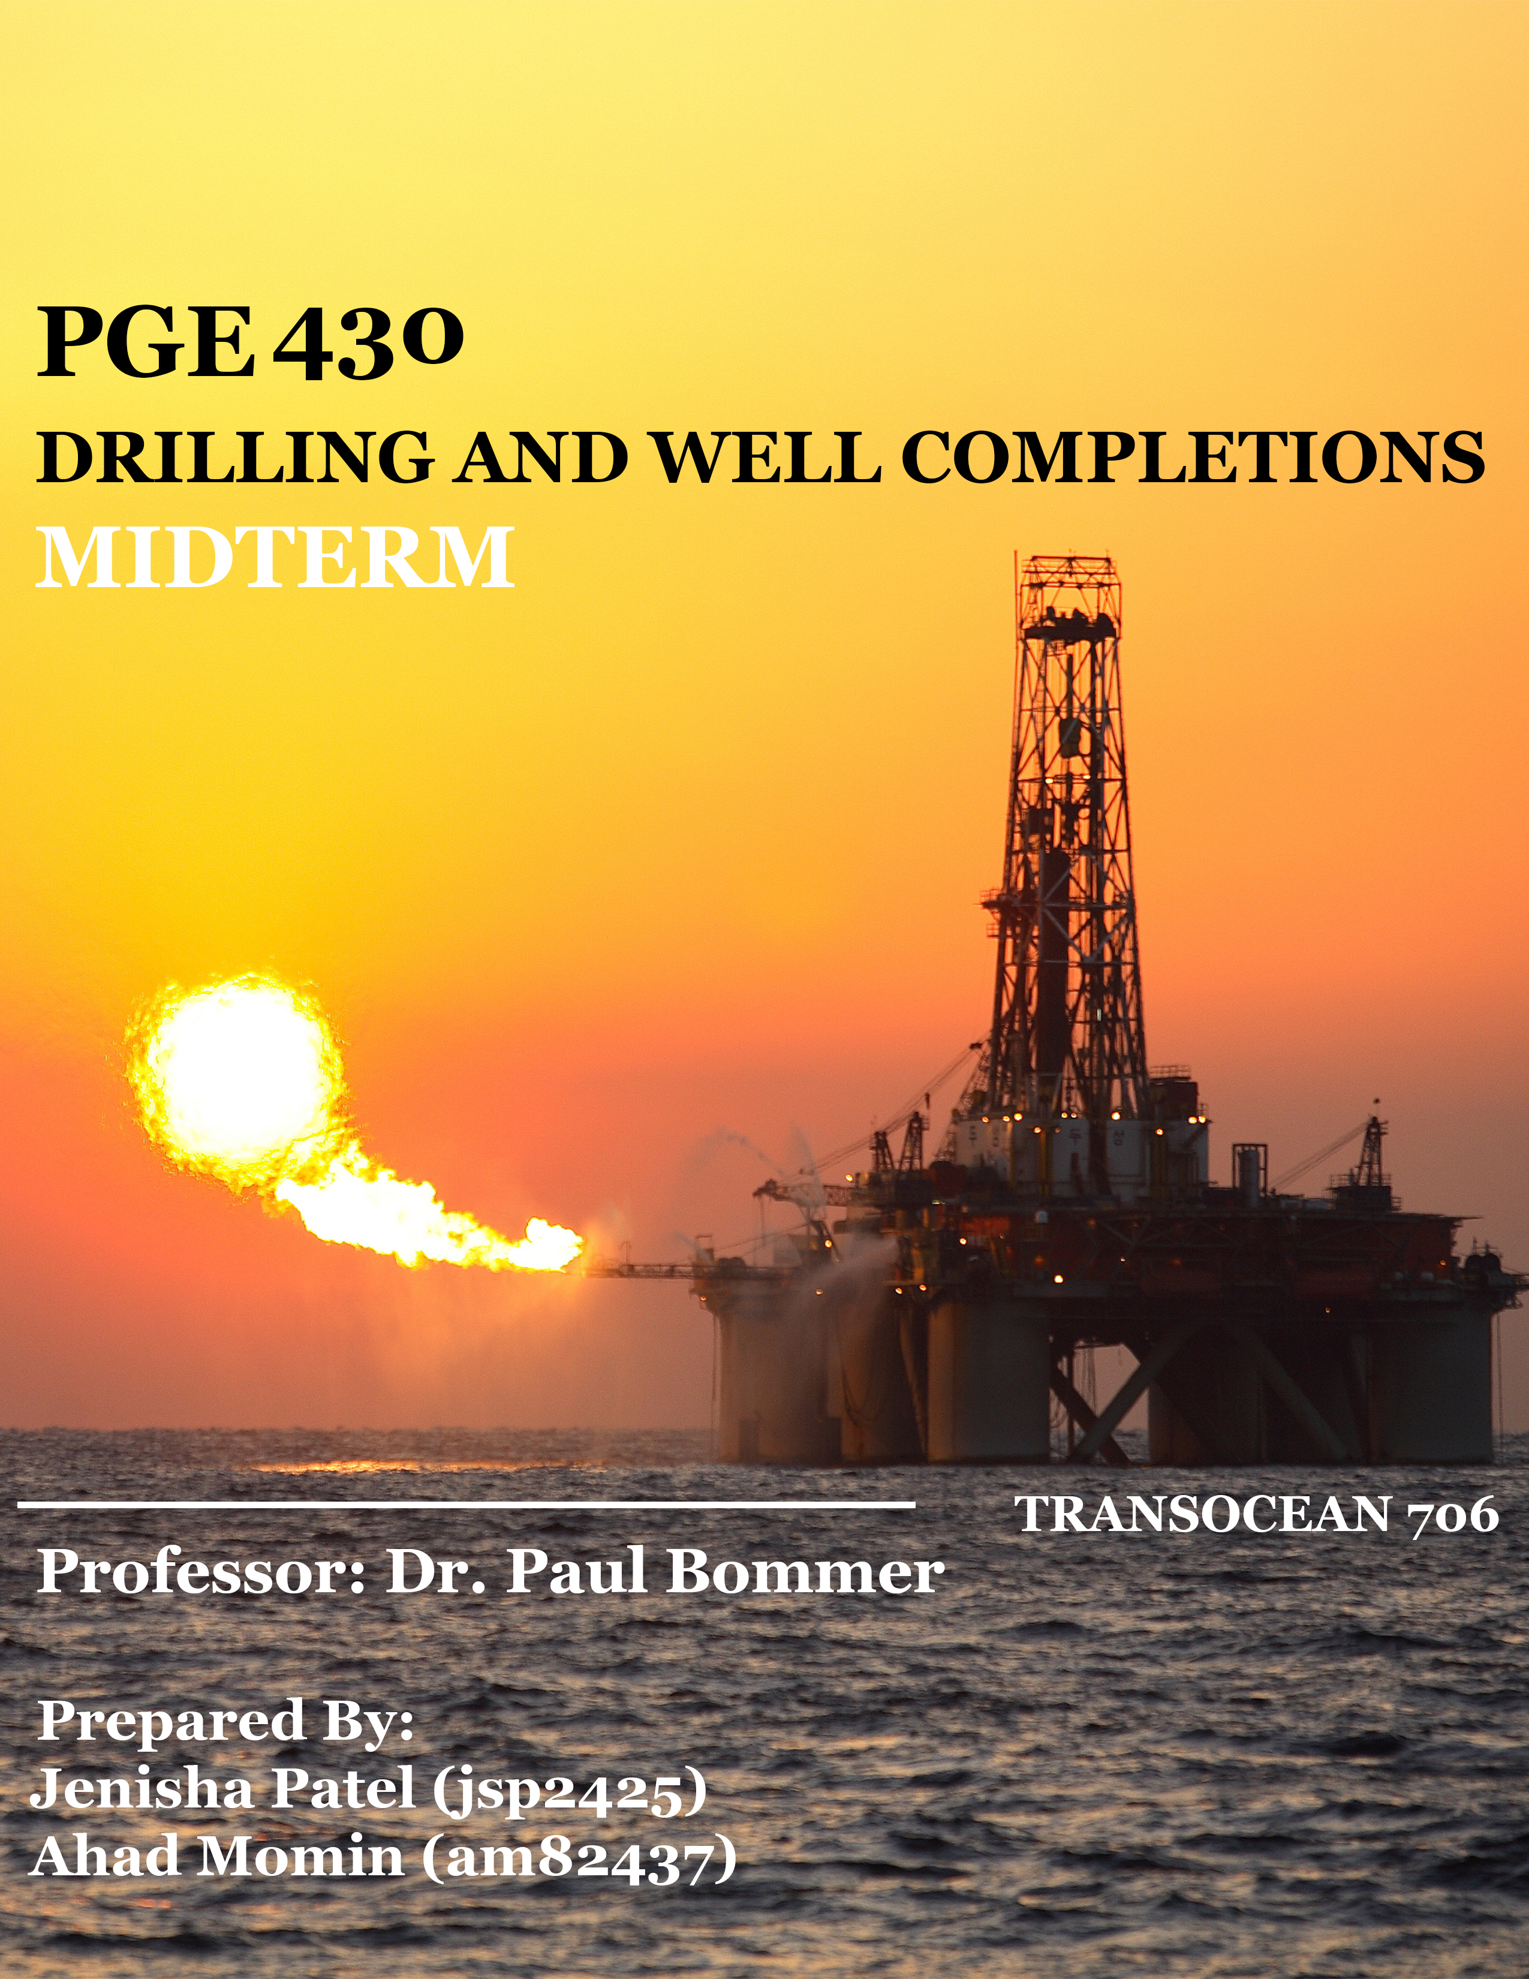

10/20/17

The University of Texas at Austin

Department of Petroleum Engineering

200 E. Dean Keeton St.

Austin, TX 78712-1585

Dear Dr. Bommer,

A comprehensive analysis of mud program and casing program was performed to drill and complete a mildly unconsolidated oil well 50 miles south of New Orleans, Louisiana in the Gulf of Mexico. After determining the mud window and casing program we were able to select Transocean 706 as the best option for drilling this well.

Although each team member made significant contributions to the both design and analysis of the drilling program, the list below highlights some of the main contributions made by each team member in both aspects of the project:

Ahad Momin performed many of the casing program calculations and selections. He also contributed by drawing some of the wellbore images and pipe program figure. He also worked on researching the optimal drill bits that needed to be used.

Jenisha Patel worked on developing the mud window and setting the stage for casing program calculations and selections of the grade of casing. She also worked on the rig selection portion and understanding various well control equipment that will benefit us in the future when we analyze ways to improve flow rate of the well.

Sincerely,

Ahad and Jenisha

MWF-11 am – 12 pm Group

**Table of Content**

|  |  |
| --- | --- |
| Introduction | 4 |
| Well Plan | 4 |
| Rig Selection | 7 |
| Mud Window | 10 |
| Pipe Program | 14 |
| Conclusion/Future Work | 24 |
| References | 26 |

**Tables**

|  |  |
| --- | --- |
| Table 1: Mud Weight Calculations | 13 |
| Table 2: Casing Strings and their respective depth ranges | 16 |
| Table 3: Casing String Diameter and Drill Bit Sizes | 17 |
| Table 4: Calculated values for collapse, burst pressure and tesile loading | 23 |
| Table 5: Catalogue values of collapse, burst and tensile loading and grade of pipe | 23 |

**Figures**

|  |  |
| --- | --- |
| Figure 1: Location of Transocean 706 | 5 |
| Figure 2: Horizontal Well Diagram | 6 |
| Figure 3: Transocean 706 | 7 |
| Figure 4: Transocean 706 Rig Details | 9 |
| Figure 5: Mud Window Plot | 14 |
| Figure 6: Casing Strings and the Seating Depths Schematic | 15 |
| Figure 7: Drill bit sizes for references | 18 |
| Figure 8: Collapse Pressure Effects on Pipe | 18 |
| Figure 9: Burst Pressure Effects on Pipe | 19 |
| Figure 10: Liner Overlap | 22 |

**Chapter 1**

**Introduction**

This chapter covers the plan for drilling a mildly unconsolidated sandstone horizontal oil well, located 50 miles south of New Orleans, Louisiana, in the Gulf of Mexico. It also covers many of the industry standards and safety regulation that are associated with drilling and completions of an oil and gas well through the calculations and design processes such as rig selection, casing program etc.

**Well Plan**

The Gulf of Mexico Basin (GOM) is one of the world's great petroleum mega-provinces, with a hydrocarbon producing history stretching more than 100 years. Despite its maturity, the Gulf remains one of the most active and successful exploration provinces in North America, attracting numerous domestic and international exploration companies (Galloway, 2009). To determine the best method of drilling a horizontal well in a mildly unconsolidated sandstone formation in GOM, we must look at and analyze the formation in which we are planning to drill.

As shown in figure 1 and 2, the well is an offshore well located 50 miles south of New Orleans, Louisiana, in 5,000 ft. of water with a total measured depth (MD) of 23,000 ft. from the derrick floor. In figure 2, we can see that the formation starts at 18,000 feet (ft.), with a reservoir dip of 3° per mile from the NE to the SW. This location is around where we intend to start the kickoff point for entry into our pay zone that is 100 ft. thick.

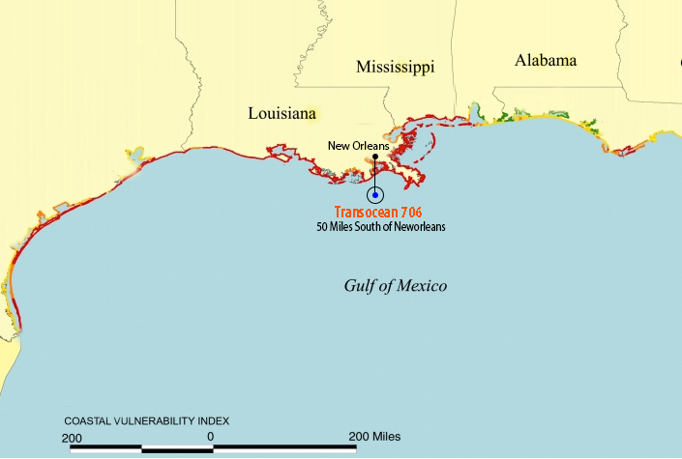Figure 1: Location of Transocean 706

Figure 2: Horizontal Well Diagram

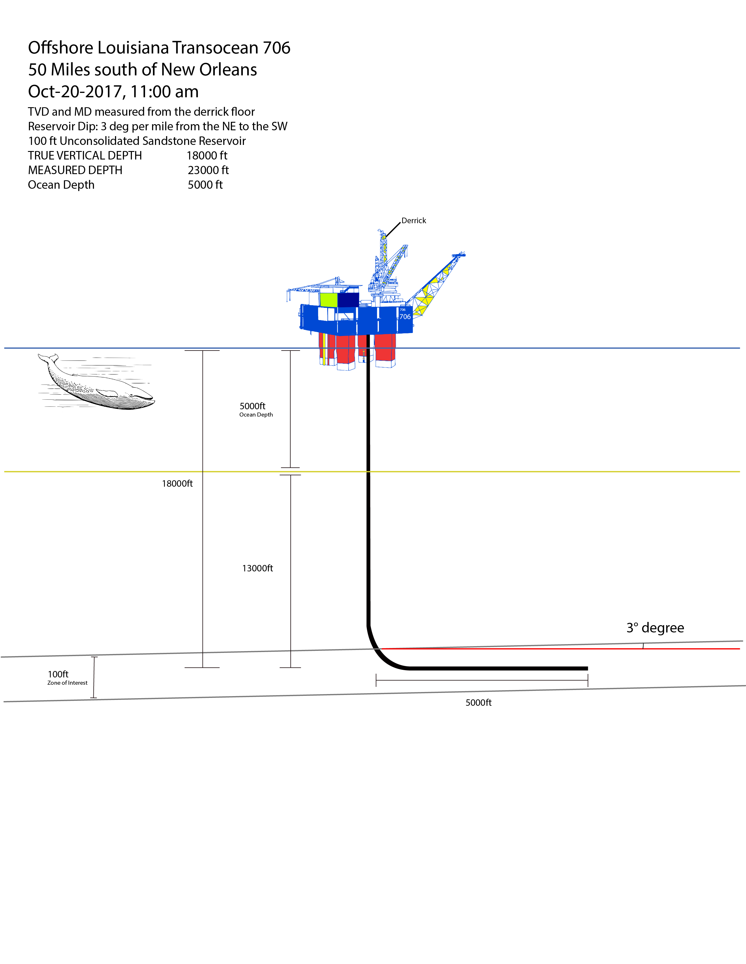

The reservoir is mildly unconsolidated sandstone and contains undersatured oil at a reservoir pressure that is above the bubble point pressure of 5,900 psia. It has a porosity of 28%, absolute horizontal permeability of 500 millidarcy (md) to air and vertical permeability of 100 md. It has a bottom hole temperature of 250 °F and initial bottom hole flowing pressure of 13,100 psia. The suggested tubing ID is 3.00” on bottom, crossing over to 4” ID.

Using this information, we will be planning out a drilling and completions program that is intended to minimize reservoir pressure drawdown while improving the flow rate. The program will discuss, the most suitable rig for the conditions listed above, and a pipe program based on the mud window calculation. This is done so that eventually in the final version, we can discuss methods that will contribute towards a drilling program that is safe, usable, cost-effective and improves flow rate.

**Rig Selection**

Figure 3: Transocean 706 (Transocea, 2017)

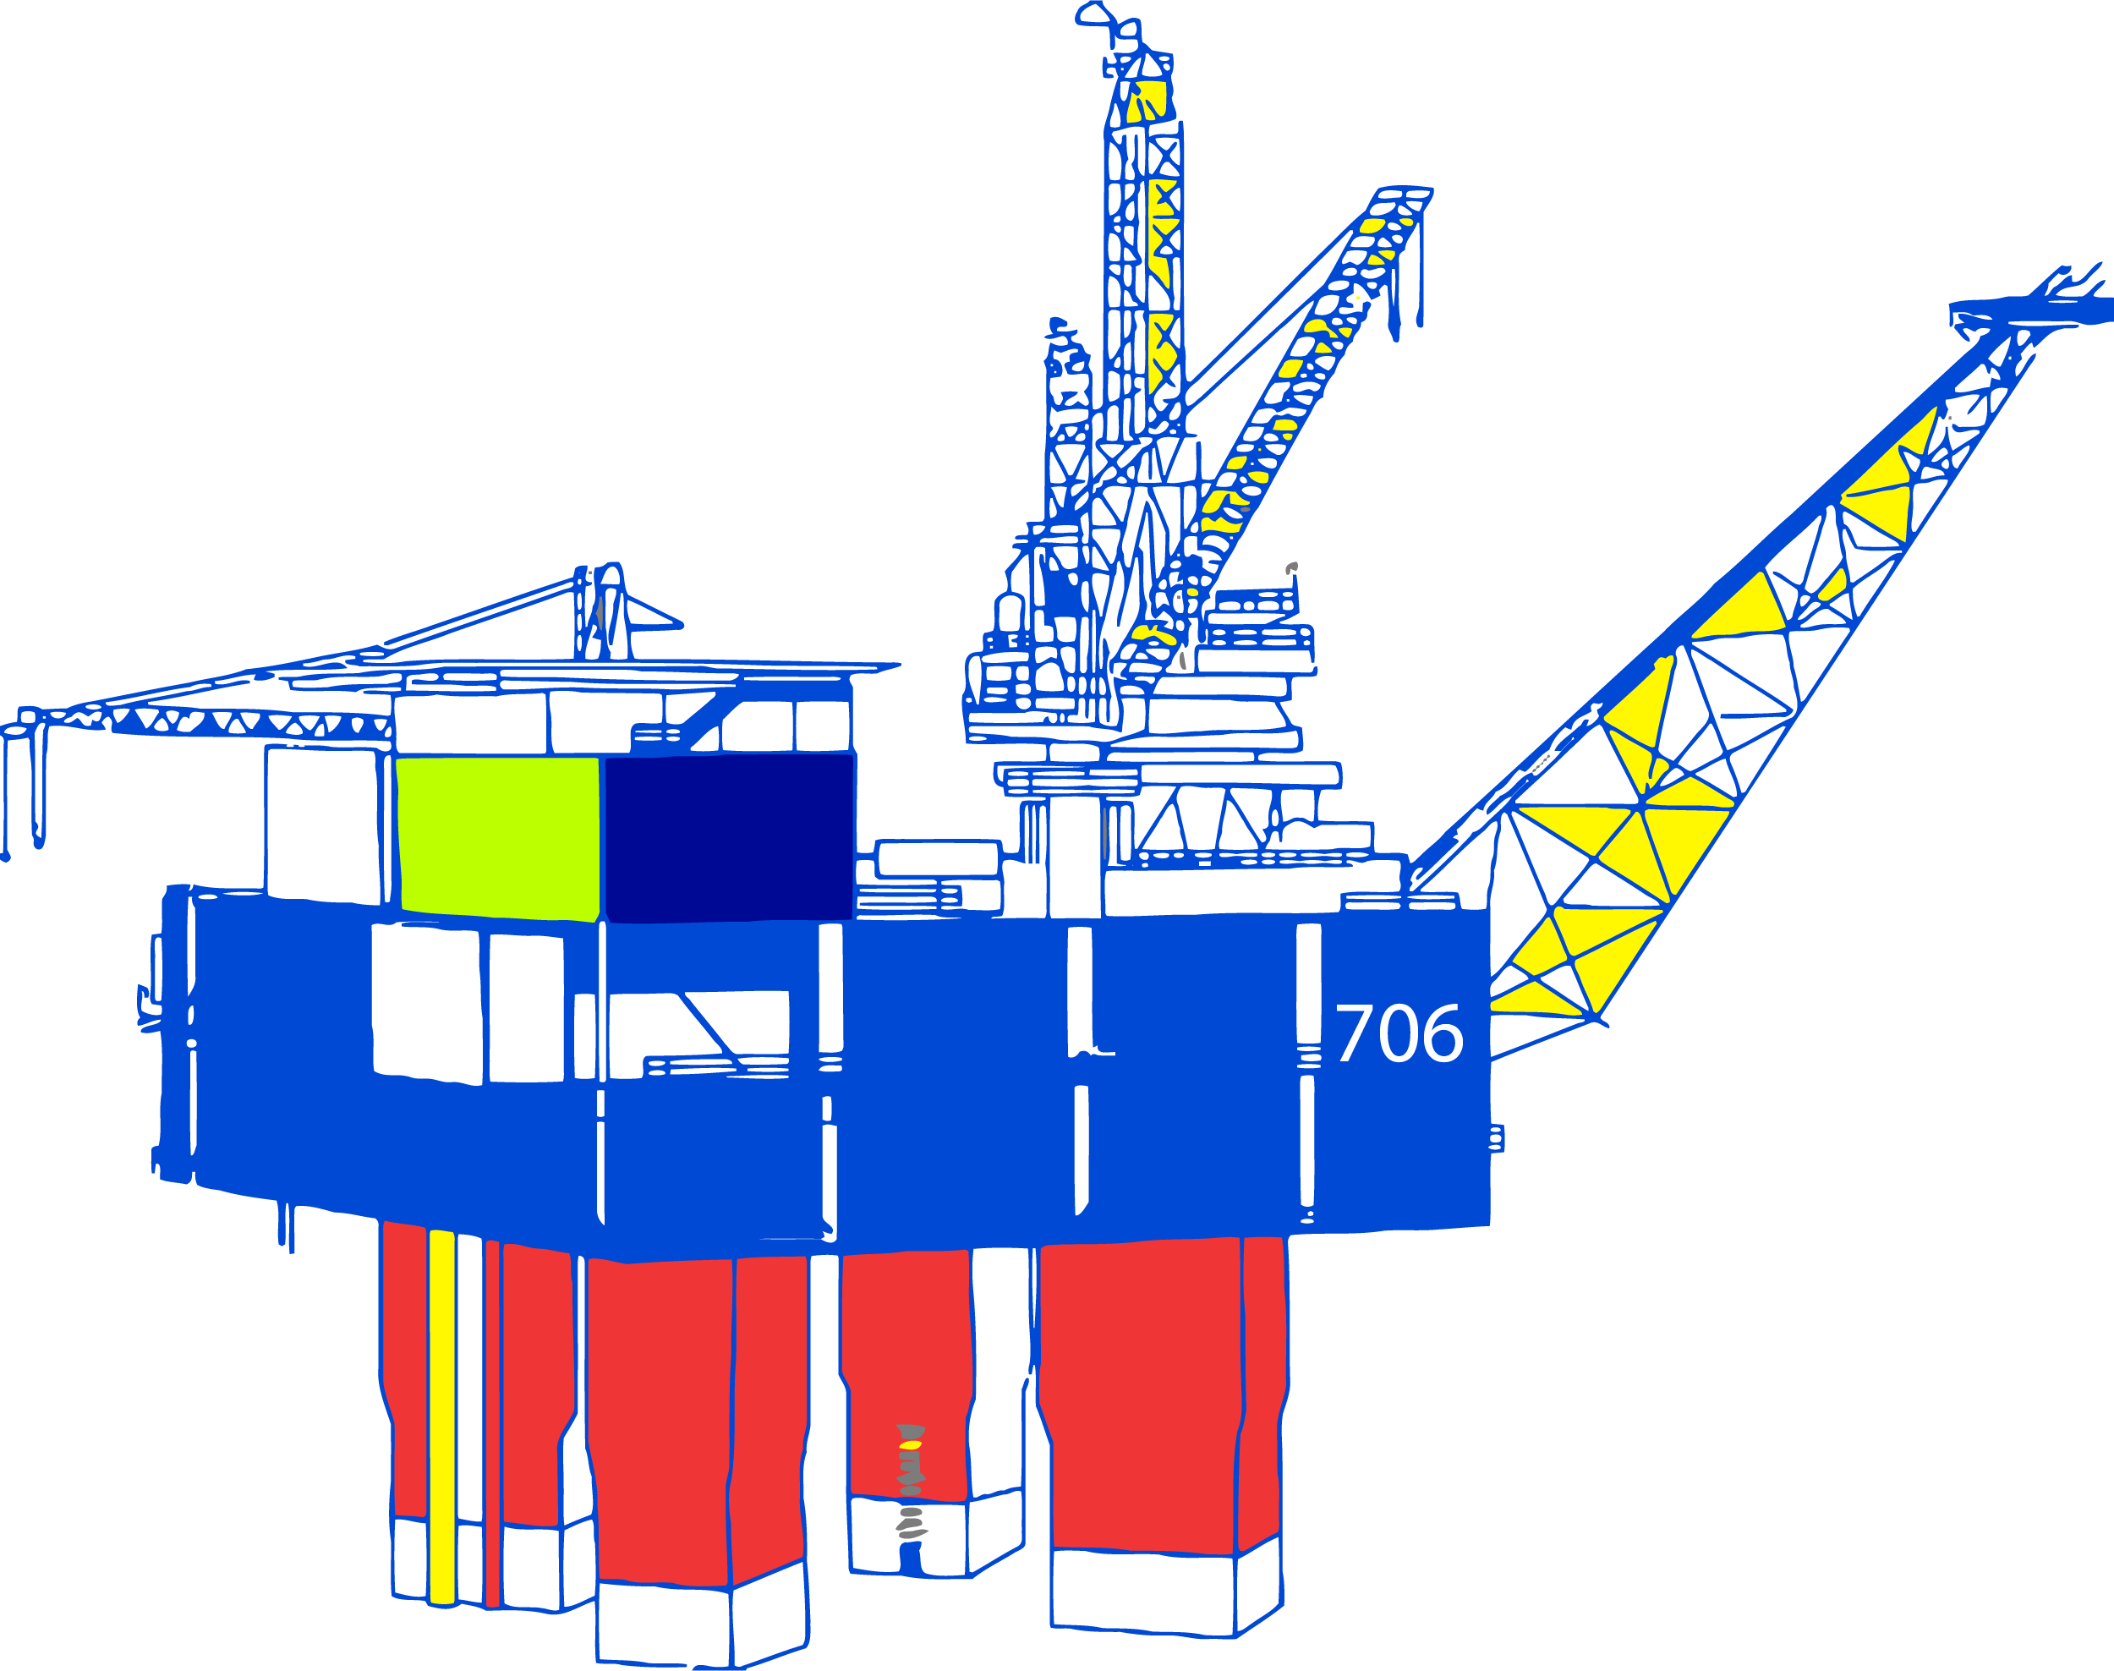

Selection of correct drilling rig is a crucial step since they are not only used to drill holes, but also to lower and cement casing in the well, and provide other functions such as well logging, and well testing (Newtas Group Oil, 2017). If a rig is improperly selected it can also cause many problems in the long run such as formation damage from poor solids control, low penetration rates, as well as high ultimate well costs and time. Therefore, while selecting a rig for this horizontal well some of the factors that were taken into consideration are: the geographical location of the well, depth of the water at which the rig will operate, the depth to the pay zone, heat and pressure of the well, the draw works and mast capacity, crown block and travelling block capacity, and the drilling line size and the pulling force.

Based on just the water depth of 5,000 ft. and the drilling depth of 18000 ft., we were able to select the submersible rig called Transocean 706 as shown in figure 3. The rig has a maximum water depth of 6,500 ft. and drilling depth of 25,000 ft. After further analyzing other information such as the derrick dimensions and the maximum hook load capacity of 1,300,000 lbs. it further strengthened our selection of this rig based on our calculation for tensile load of casing string 3 which happens to have maximum weight of pipe including the drill string. Some of the other aspects that further verify our selection of this rig are the rig’s station keeping system such as the mooring system that has electric drum winches with 1,000,000 lbs. static brake capacity, its 3 inch stud link chain. As well as, the Dynamically Positioned (DP) System with triple redundancy and its eight 2,800 kW azimuthing thrusters, these tell us that the platform will be stable even in inclement conditions like wind and current power as well as ship movement (Transocean, 2017).

Other aspects that prove Transocean 706 to be a reliable offshore rig for this project are the drawworks is rated to be able to operate up to 3,000 hp and 14 1¾-inch drilling lines. It also has a hydraulic rotary table with a 60½-inch diameter, which tells us that the pipe and tubing, as well as drill bits will not have any problem fitting since the biggest diameter equipment we will be lowered through it is 26”. Surface well control equipment such as the Blow Out Preventers (BOPs) was also taken into consideration when selecting this rig. The Transocean 706 has an annular BOP that has a working pressure of 10,000 psi and BOP rams that is a 5 ram preventer system with a working pressure of 15,000 psi (Transocean, 2017). Based on these dual variable bore rams BOP we know in case we do have a problem; we will be able to shut in flow by closing the BOP valves and prevent any mishaps since it features a larger reservoir of packer rubber. This will ensure us a long lasting seal as when we close the BOP valve, it will activate the packers and the rubber inserts are displaced inward to close the packer around the pipe, sealing any flow of fluid (Transocean, 2017). The detailed pamphlet about Transocean 706 is also shown in figure 4 below.

Figure 4: Transocean 706 Rig Details (Transocean, 2017)

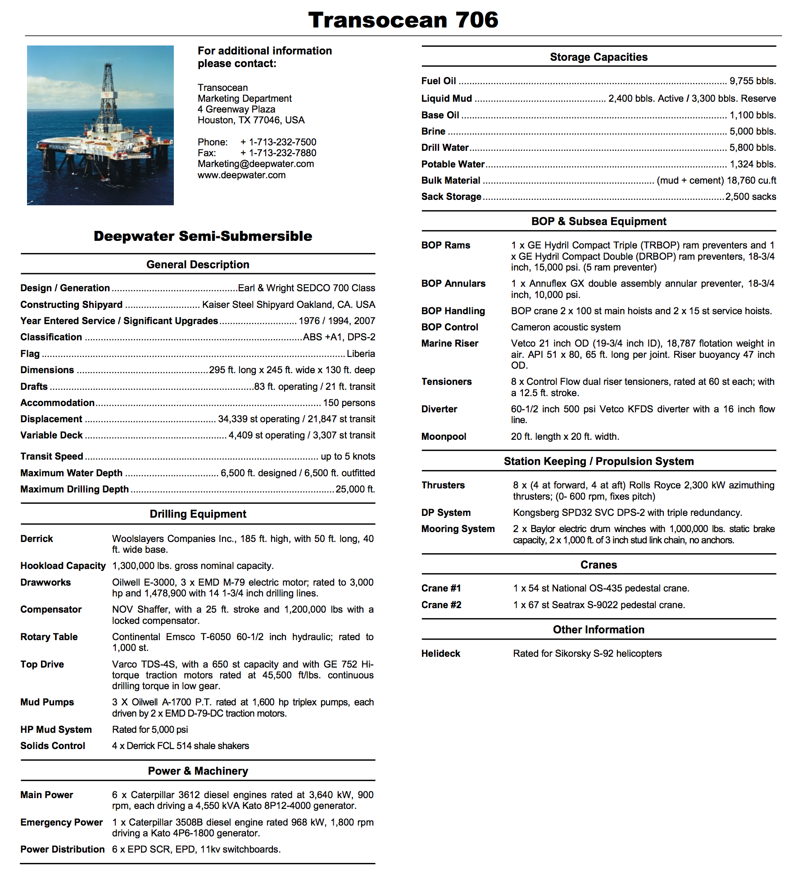

**Mud Window**

While drilling, the first thing we need to be conscious of is how to keep the wellbore stable. Since we are drilling through unconsolidated sandstone, we need to make sure that the well does not cave in and that a proper seal is installed once the drilling of a section is complete. In order to do this we need to select proper grade steel pipe that will be cased with cement at appropriate depths. These depths are called casing points. The casing points are then drilled using a drilling fluid that has high enough density to prevent the pore fluids to flow into the well, prevent fractures and wellbore collapse. Sometimes it is possible to get the mud weight in wellbore so high that it causes the rock to fracture, similar to hydraulic fracturing. This can cause loss circulation in the wellbore, and in extreme cases it causes the bottom hole pressure to decrease and cause a blowout. Therefore, to determine an appropriate “window” of mud weight that will allow us to drill and prevent any problems we first determined the pore pressure and the frac pressure at every depth from the ocean floor (5000 ft.) to the zone of interest (18000 ft.).

In order to determine the frac and pore pressure we performed multiple stages of calculations. First, we calculated the true vertical depth increments by using equation 1. Where, TVD (true vertical depth) is the total depth from the ocean floor to the zone of interest, which is the unconsolidated sandstone formation where we intend to drill horizontally. And the number 24 is just the number of depth intervals we wanted, but that number can be decreased or increased based on personal preference.

$TVD Increment \left(ft\right)= D_{SW}+ \frac{TVD-D_{SW}}{24}$*(Eq. 1)*

*DSW = Sea Water Depth (ft.) = 5000 ft.*

*TVD = True Vertical Depth (ft.) = 18000 ft.*

Then, according to the well plan we used normal pore pressure gradient of 0.465 psi/ft. for up to a depth of 6000 ft. And for the depths below 6000 ft., the pore pressure is increases linearly up to the TVD, where the gradient is 0.65 psi/ft., therefore equation 2 is used to calculate the gradient. Using equation 2, we calculated the pore pressure at each depth using equation 3.

*Derivation of equation 2*

$$∇p_{fluid}= m*\left(TVD \right)+ b$$

*0.465 psi/ft. = m*(6000 ft.) + b*

*0.65 psi/ft. = m*(18000 ft.) + b*

$∇p_{pore fluid}= \left(1.54E-05\right)*\left(TVD \right)+ 0.3725$*(Eq. 2)*

${ P }_{pore}=$*TVD (ft) $∇p_{pore fluid}$* (Eq. 3)*

$$∇p_{pore fluid}=Normal Pore Pressure gradient (\frac{psi}{ft})$$

$P_{pore}=Pore Pressure (psi)$

Using the pore pressure that was calculated, we determined the pore mud weight of the fluid using equation 4. Where, we assumed a pore safety margin of 0.5 ppg to prevent any fluid flow or compressive wellbore failure (Bommer, Wellbore architecture, 2017).

$MW=\frac{P_{pore }}{TVD}*\left(\frac{8.33 ppg}{0.433 (\frac{psi}{ft})}\right)+{SM}_{pore}$ (*Eq. 4)*

*MW = Mud Weight (ppg)*

$$P_{pore}=Pore Pressure (psi)$$

$${SM}_{pore}= pore safety margin \left(ppg\right)=0.5 ppg$$

*TVD = True Vertical Depth (ft.)*

The frac mud weight is important in helping us determine the casing points since it is essentially the total pressure represented as fluid density, above which leak off or formation damage may occur. So, it helps us to determine what mud weight we should use to stay below the fracture mud weight and above pore mud weight to work inside the mud window.

We first calculated the over burden pressure, over burden gradient as shown in equation 5, and 6 respectively. For these calculations, we assumed ϒSW (salt water specific gravity) as 1.02 and the ϒOB (overburden or sediment specific gravity) as 2.3 (Bommer, Wellbore architecture, 2017).

$σ_{OB}=0.433*D_{SW}*γ_{SW}+0.433*γ_{OB}*(TVD-D_{SW})$ (Eq. 5)

$$σ_{OB}=Over burdern stress \left(psi\right)$$

$$γ_{SW}=sea water specific gravity=1.02$$

$$γ_{OB}=overburden specific gravity=2.3$$

$∇p_{OB}=\frac{σ_{OB}}{TVD}$ (Eq. 6)

$$∇p_{OB}=Over burden pressure gradient \left(\frac{psi}{ft}\right)$$

Additionally, fracture gradient was estimated using Zoback’s Equation as shown below.

$∇p_{frac}=0.32*\left(∇p_{OB}- ∇p_{pore}\right)+ ∇p_{pore}$ (Eq. 7)

$$∇p_{frac}=frac gradient (\frac{psi}{ft})$$

Finally using the frac gradient, we determined the frac mud weight as shown in equation 8. We assumed 0 frac safety margin, since we had already accounted for safety in the pore mud weight calculation.

${MW}_{frac}=∇p_{frac}*\left(\frac{8.33 ppg}{0.433 \left(\frac{psi}{ft}\right)}\right)-{SM}_{frac}$ (Eq. 8)

$${MW}_{frac}=frac mude weight \left(ppg\right)$$

$${SM}_{frac}=frac safety margin$$

Table 1 shows the calculated pore mud weight and frac mud weight at each depth from 5000 ft. to 18000 ft., and figure 4 shows the corresponding mud window plot.

Table 1: Mud Weight Calculations

|  |  |  |  |  |  |  |  |
| --- | --- | --- | --- | --- | --- | --- | --- |
| **TVD (ft.)** | **Pore Grad (psi/ft.)** | **Pore Press (psi)** | **Mud Wt (ppg)** | **OB Pressure (psi)** | **OB Grad (psi/ft.)** | **Frac Grad (psi/ft.)** | **Frac MW (ppg)** |
|
| 5000.00 | 0.47 | 2325.00 | 9.45 | 2208.30 | 0.44 | 0.46 | 8.80 |
| 5541.67 | 0.47 | 2576.88 | 9.45 | 2747.75 | 0.50 | 0.47 | 9.14 |
| 6083.33 | 0.47 | 2835.95 | 9.47 | 3287.19 | 0.54 | 0.49 | 9.43 |
| 6625.00 | 0.47 | 3143.73 | 9.63 | 3826.64 | 0.58 | 0.51 | 9.76 |
| 7166.67 | 0.48 | 3460.54 | 9.79 | 4366.08 | 0.61 | 0.52 | 10.07 |
| 7708.33 | 0.49 | 3786.40 | 9.95 | 4905.53 | 0.64 | 0.54 | 10.34 |
| 8250.00 | 0.50 | 4121.29 | 10.11 | 5444.98 | 0.66 | 0.55 | 10.60 |
| 8791.67 | 0.51 | 4465.21 | 10.27 | 5984.42 | 0.68 | 0.56 | 10.83 |
| 9333.33 | 0.52 | 4818.18 | 10.43 | 6523.87 | 0.70 | 0.57 | 11.06 |
| 9875.00 | 0.52 | 5180.18 | 10.59 | 7063.31 | 0.72 | 0.59 | 11.27 |
| 10416.67 | 0.53 | 5551.22 | 10.75 | 7602.76 | 0.73 | 0.60 | 11.46 |
| 10958.33 | 0.54 | 5931.29 | 10.91 | 8142.20 | 0.74 | 0.61 | 11.65 |
| 11500.00 | 0.55 | 6320.40 | 11.07 | 8681.65 | 0.75 | 0.62 | 11.84 |
| 12041.67 | 0.56 | 6718.55 | 11.23 | 9221.10 | 0.77 | 0.62 | 12.01 |
| 12583.33 | 0.57 | 7125.73 | 11.39 | 9760.54 | 0.78 | 0.63 | 12.18 |
| 13125.00 | 0.57 | 7541.95 | 11.55 | 10299.99 | 0.78 | 0.64 | 12.35 |
| 13666.67 | 0.58 | 7967.21 | 11.72 | 10839.43 | 0.79 | 0.65 | 12.51 |
| 14208.33 | 0.59 | 8401.51 | 11.88 | 11378.88 | 0.80 | 0.66 | 12.67 |
| 14750.00 | 0.60 | 8844.84 | 12.04 | 11918.33 | 0.81 | 0.67 | 12.82 |
| 15291.67 | 0.61 | 9297.21 | 12.20 | 12457.77 | 0.81 | 0.67 | 12.97 |
| 15833.33 | 0.62 | 9758.61 | 12.36 | 12997.22 | 0.82 | 0.68 | 13.12 |
| 16375.00 | 0.62 | 10229.05 | 12.52 | 13536.66 | 0.83 | 0.69 | 13.26 |
| 16916.67 | 0.63 | 10708.53 | 12.68 | 14076.11 | 0.83 | 0.70 | 13.40 |
| 17458.33 | 0.64 | 11197.05 | 12.84 | 14615.55 | 0.84 | 0.70 | 13.54 |
| 18000.00 | 0.65 | 11694.60 | 13.00 | 15155.00 | 0.84 | 0.71 | 13.68 |

Figure 5: Mud Window Plot

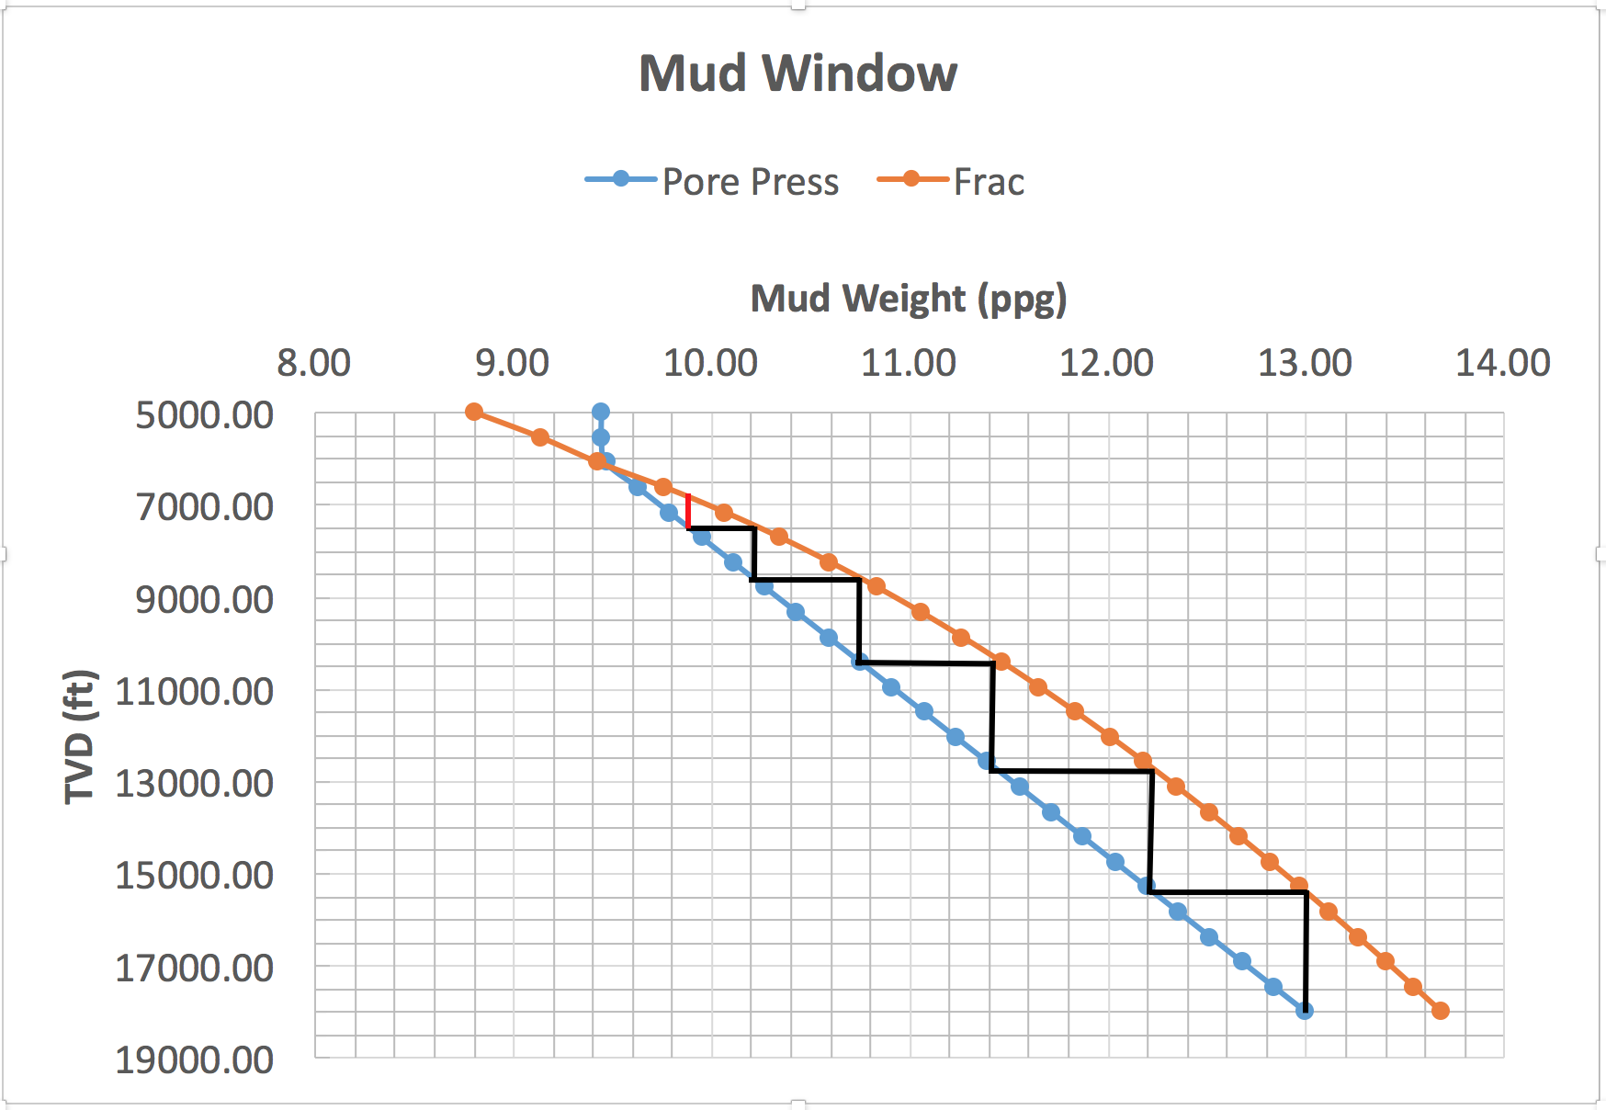

After plotting the mud weights for pore and frac, we get a mud window with appropriate kick and trip margins. This helps us to determine how many casing strings we need for this horizontal well at each depth. For our case we calculated total of 7 casing strings including surface and conductor. The casing design will be discussed further in the next section titled pipe program.

**Pipe Program**

Designing a proper casing program is extremely important in any type of oil and gas well design, since it ensures that the shallow formations are protected from the high pressures of the deeper zones. Casing will also allow us to seal off the freshwater zones and isolate the producing zones (Bommer, Casing Design, 2017). Casing being one of the most fundamental parts of a well design and important part of drilling, it needs to be perfectly designed, and cemented before we run our production tubing and start completing the well.

In order to determine the best pipe program, we first configured the casing depths using the mud window plot. The flat part of the black stair-steps line shown in figure 5 in the mud window plots showing the casing seating depth. Those depths essentially met the criteria of us not going above the frac pressure, since if we were to use mud that is above the frac mud weight, it would fracture the formation, which could cause many problems such as loss of circulation or pressure changes. Using the pore pressure and frac pressure calculated at each depth we were able to determine that we need total of 7 casing strings, which includes both the surface and conductor casing. Since, there are only three slots in the wellhead to cement and run the casing all the way to the top of the well, we decided to use 2 liners and 5 casing strings. The casing depths are also shown in figure 6 and table 2 for reference purposes.

Figure 6: Casing Strings and the Seating Depths Schematic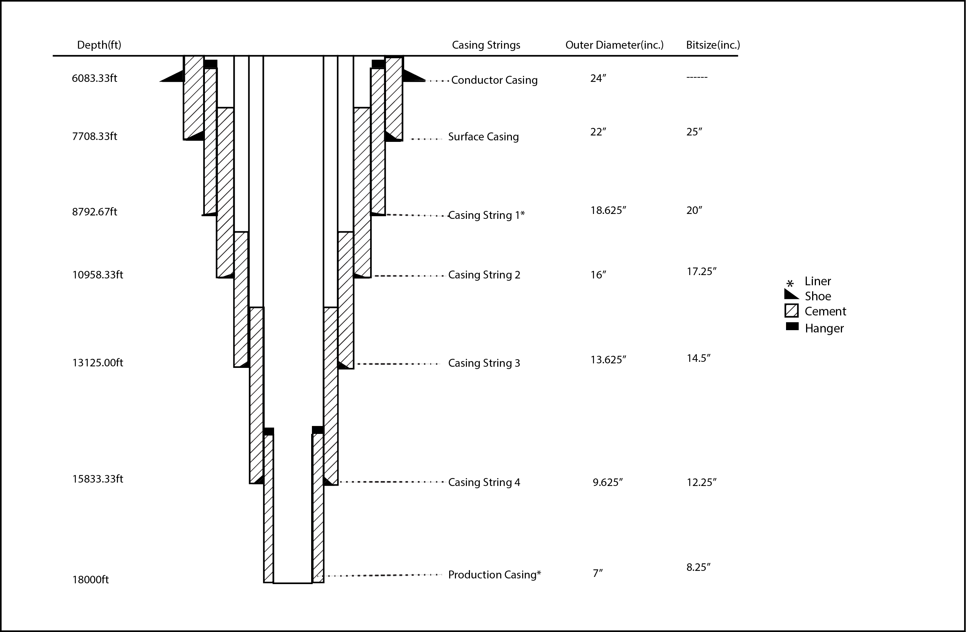

Table 2: Casing strings and their respective depth ranges (only vertical well section considered for now)

|  |  |
| --- | --- |
| **Casings** | **Depth (ft)** |
| Conductor Casing | 5000 - 6083.33 |
| Surface Casing | 5000 - 77083.33 |
| Casing string 1(Liner) | 7308.33 - 8791.67 |
| Casing string 2 | 5000 - 10958.33 |
| Casing string 3 | 5000 - 13125.00 |
| Casing string 4 | 5000 - 15833.33 |
| Production Casing(Liner) | 15333.33 - 18000 |

Before proceeding to calculate the pressures and tensile loading, we first evaluated the outer diameters and drill bit sizes of the pipes that we should use to make the casing design effective. To meet the suggested tubing ID of 3.00” on bottom crossing over to 4.00” ID., we used Halliburton Redbook to get an production tubing that has an OD of 3.50” and ID of 3.00”, at an weight of 10.3 lbs./ft. (ppf). From the ID of the tubing, we were also able to obtain the coupling diameter, which is the diameter of the tubing at the joint; in our case it is 4.5”. One of the considerations that were put into the tubing selection was the weight of the pipe. Since the higher the weight of the pipe, the thicker the pipe, it would also mean more expensive, and since we are also trying to minimize the cost of the project as engineers it is important that we meet all the safety criteria as well as be more cost efficient.

Usually when designing the casing program, you go from the bottom of the well to the surface. Therefore, we first established a production casing of 7”. This was done by taking into account the coupling of the production tubing, which is smaller than the inner diameter of the production casing. This established that the tubing will easily fit into our production casing.

Once the production casing of 7” was selected we decided on the sizes of the corresponding casing strings above it to fit a drill bit that is approximately 1” larger than the casing diameter to make sure that when we cement the string, we have 1” of it that surrounds the outside of the casing. As we drill deeper the wellbore diameter decreases therefore after figuring out the total diameter of the production casing, we moved on to the next casing string, which is our casing string 4. We used 12.25” bit to install 9.625” of casing string 4. Based on this same analogy our casing string 3 of 13.625” will be installed using drill bit of 14.5”, this is also our first liner. Then casing string 2 of 16” was installed using, 17.25” drill bit. The same method was used to install the rest of the other casing strings, which is also shown in table 3 for each corresponding casing seating depth.

One of the important design consideration is the coupling diameter of the casing. We need to make sure that the internal diameter of the casing string above the interested casing string is large enough to fit the coupling diameter of the casing below it. Also, another aspect that was considered is that the diameter of the drill bit size selected for the production casing is less the internal diameter of casing string 4 and so on to keep on drilling to the reservoir. The casing diameter, corresponding drill bits size and coupling diameter for each of the casing string was obtained from table 7.7 and 7.8 of the Applied Drilling Textbook (Adams, Keith, & et. al., 1986). The casing string outer diameter and the drill bit size at each depth are also shown in figure 7.

Table 3: Casing String Diameter and Drill Bit Sizes

|  |  |  |  |  |  |  |
| --- | --- | --- | --- | --- | --- | --- |
| **Casing String No.** | **TVD (ft.)** | **OD (in.)** | **ID (in.)** | **Coupling Diameter (in.)** | **Drift Diameter (in.)** | **Drill Bit Size (in.)** |
|
| Production Casing String 5 | 18000 | 7 | 6.184 | 7.656 | 6.059 | 8.25 |
| Casing String 4 | 15833.33 | 9.625 | 8.535 | 10.625 | 8.379 | 12.25 |
| Casing String 3 | 13125 | 13.625 | 12.375 | 14.375 | 12.188 | 14.5 |
| Casing String 2 | 10958.33 | 16 | 14.876 | 17 | 14.869 | 17.25 |
| Casing String 1 | 8791.67 | 18.625 | 17.375 | 19 | 17.188 | 20 |
| Surface Casing | 7708.33 | 22 | 20.75 | 23 | 20.563 | 25 |
| Conductor Casing | 6083.33 | 26 | 23.5 |  |  | Pounded IN |
| 5000 |  |  |  |  |  |

Figure 7: Drill bit sizes for references (not necessarily the type of drill bits used for this project) (not scale), (Varel Oil and Gas, 2016)

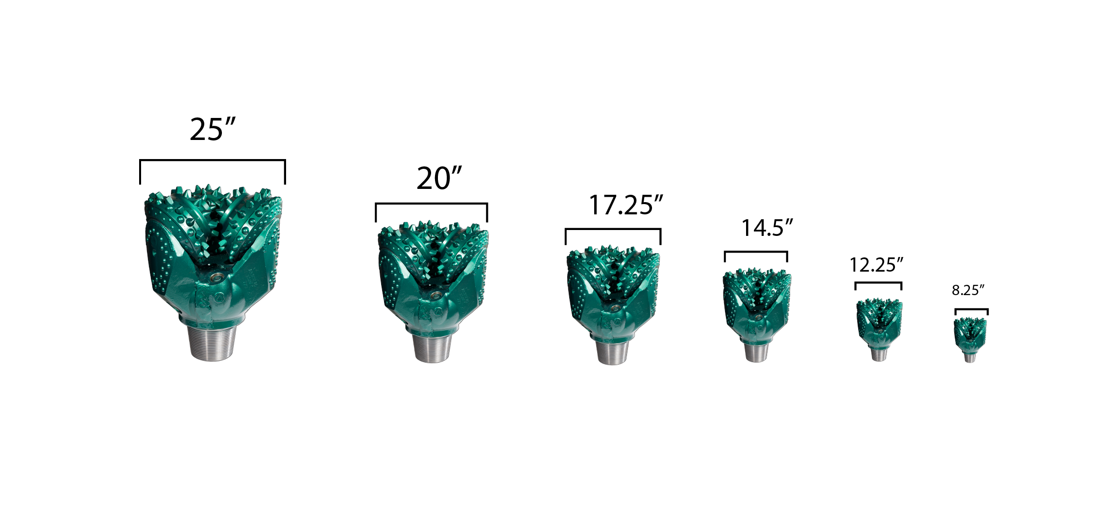

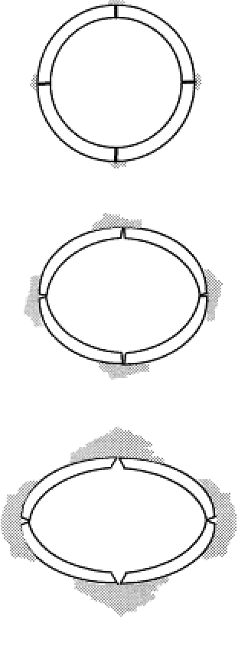Now finally after getting OD’s and pipe depths we perform calculations for Collapse, Burst and Tensile loading and compare it with the Tenaris API steel pipe catalog to help us determine which pipe grade fits best for each casing strings. We have assumed our drilling fluid as seawater, which has a specific gravity of 1.02 for surface casing and oil base mud from casing string 1 to production casing, which has a specific gravity of 0.85. We ignore the pressure changes due to cooling and heating of the well but most of the time, the well is in thermal equilibrium unless it’s a well in a geothermal reservoir or when we are injecting a cold fluid. Overall, we are designing a pipe which can goes to worst-case scenario (Boomer, Casing Design, 2017).

In a well where we have numerous casing strings and large depths, we want to economize. Though our calculations of pressure resistance we looked around different kinds of casing that has the same OD but different strengths, weights, inner and drift diameters to provide us to get deeper and save money. However, in an offshore rig, casing cost is inconsequential so when we find a pipe collapse, burst and tensile resistance, we are in Business.

We determined the right grade and weight of pipe by first calculating some of the design criterion such as the collapse pressure, burst pressure, and tensile load.

*Collapse Pressure*

Collapse pressure is the pressure at which the casing, or pipe will catastrophically deform as a result of differential pressure acting from outside to inside of the tube. So it’s very important to determine the collapse pressure of the pipe steel that we are choosing. Figure 8 shows how the pipe under a collapse pressure changes its shape over time.

Figure 8: Collapse Pressure Effects on Pipe

Normally in our case, we don’t want anything inside our casing but we use seawater and oil based mud so we can easily find the steel for casing strings that has a collapse pressure resistant at least to the calculated pressure. Next we included a safety factor for the casing of 1.125 to prevent a collapse.

From Casing String 1 to Production Casing:

$P_{c}={SF(P}_{e}-P_{i})=1.125*TVD*\left(\frac{MWpore}{8.33}\right)*\left(0.433\right)- 1.125*\left(TVD\right)*\left(γ_{oil}\right)*(0.433)$*(Eq. 9)*

$$P_{c}=Collapse Pressure \left(psi\right)$$

$$P_{e}=External Pressure \left(psi\right)$$

$$P_{i}=Inside Pressure (psi)$$

$SF=1.125$*(Traditional Industry used safety factor)*

$$γ_{oil}=Diesel Oil Specific Gravity=0.85$$

$$MWpore=Pore mud weight (ppg)$$

For Surface Casing:

$P_{c}={SF(P}_{e}-P_{i})=1.125*TVD*\left(\frac{MWpore}{8.33}\right)*\left(0.433\right)- 1.125*\left(TVD\right)*\left(γ_{SW}\right)*(0.433)$

$$γ_{SW}=Sea Water Specific Gravity=1.02$$

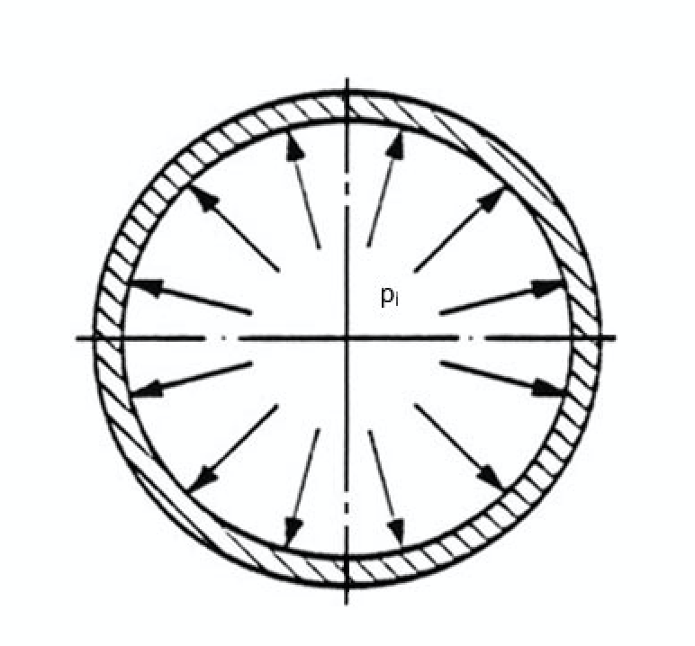The calculated collapse pressure value was then compared to API Steel Casing collapse pressure rating of the casing provided by the manufacturer, Tenaris.

*Burst Pressure*

Casing burst pressure is theoretically the internal pressure at which a joint of casing will fail. The casing burst pressure value is a key consideration in our offshore well-control and contingency operations and is a major factor in the well designing process.

Figure 9: Burst Pressure Effects on Pipe

We calculate our burst pressures using the equation 10 below:

$Burst Pressure\left(Pb\right)=SF\left(Pi-Pe\right)$ (Eq. 10)

Where;

$SF=Safety Factor= 1$*(Even if we exceed the minimum steel strength the pipe won’t rupture or burst)*

$$Pi=TVD*\frac{MWfrac}{8.33}*0.433$$

$$Pe=(Top depth of the pipe)*γ_{SW}/γ_{Oil}*0.433$$

For example: production pipe = Casing string 4 TVD – 500 ft. (liner overlap)

We don’t use the safety factor for burst because if we see the Barlow’s equation 11, below the material strength, it is defined by the minimal yield strength, which is by definition the end of the elastic limit. It’s not where we think the steel is going to fail so there is considerable safety in that notion, where the strength of the pipe is not really calculated to the point of failure its calculated at the end of the elastic limit that’s why we use safety margin.

$Burst Pressure(psi)=\frac{2*1\left(Safety Factor\right)*\left.Minimum Yield Strength(psi)\right.*thickness(in)}{Outer Diameter of the Pipe(in)}$ (Eq. 11)

In calculating burst pressure our internal pressure is higher than the external pressure. The burst load is different on the top of the casing and at the bottom of the casing and we take the burst pressure at the top (equation 12) because that’s where it’s maximum. For the worst case we need to consider that maximum burst pressure. As we go shallower in the casing string, the burst pressure requirement increases. This is because the assumption that the internal pressure (Pi) remains constant throughout the casing string, however the external pressure calculation is different at the top and the lower end of the pipe. External pressure is the function of hydrostatic pressure and at lower depth it is minimum and at higher depth it is maximum. Ultimately, we get a higher burst pressure when we consider minimum external pressure. For example, for casing string 2 our top depth is 5000 ft. so plugging in the (Pe) formula we get the maximum burst pressure.

From Casing String 1 to Production Casing:

${ P}_{b,top}=TVD*\left(\frac{MW_{frac}}{8.33}\right)*(0.433)-(D) \left(\frac{ρ_{oil}}{8.33}\right)*(0.433)$ (Eq. 12)

$$P_{b,top}=Burst Pressure at the top of the casing (psi)$$

$$ρ_{oil}=Diesel oil density=7 ppg$$

$$D= top of the pipe to the casing length (ft)$$

For Surface Casing:

$$P_{b, top}=TVD*\left(\frac{MW_{frac}}{8.33}\right)*(0.433)-(D) \left(γ_{SW}\right)*(0.433)$$

$$γ_{SW}=Sea Water Specific Gravity=1.02$$

$$D= top of the pipe to the casing length (ft)$$

However, for casing string 1 and Production casing which are liners, we have a special case. Since the liners are not hanged all the way to the top we have the surface casing and casing above the production exposed. The Pi at the liners will be same as the Pi of surface and casing string 4 respectively, which is dangerous (high frac pressures of liners affects the casing above the liner). The exposed surface casing and casing string 4 is sensitive to the frac pressure of the shoe of the next deepest casing. To take care of that we needed burst pressure of surface and casing string 4 to withhold the burst pressures of the liners (next deepest casing).

Therefore, for the calculations of burst pressure (equation 13) for the casing string 4 and surface casing we took the Pi pressure for the liners attached to them. But for other casings we calculated burst pressure by calculating Pi at their own depth since they run all the way to 5000 ft.

For Casing String 4 (Liner)

${ P}_{b}=$ $TVD*\left(\frac{MW_{frac, n-1}}{8.33}\right)*(0.433)-(D) \left(\frac{ρ_{oil}}{8.33}\right)*(0.433)$ (Eq. 13)

$$MW_{frac, n-1}=Frac mud weight in the casing below string 4 (production casing string 5)$$

$TVD=TVD of the liner (ft)$

For Surface Casing (Liner):

$$P_{b,}=TVD*\left(\frac{MW_{frac, n-1}}{8.33}\right)*(0.433)-(D) \left(γ_{SW}\right)*(0.433)$$

$$MW_{frac, n-1}=Frac mud weight in the casing below surface casing (casing string 1)$$

$TVD=TVD of the liner (ft)$

Again the calculated burst pressure values were then compared to API Steel Casing burst pressure rating of the casing provided by the manufacturer, Tenaris.

*Tensile Load*

Finally we determined the tensile strength of each pipe using trial and error method as well as comparing the burst and collapse pressure, we were able to calculate the tensile loading of each casing string using the equation 14 below. Where we plugged in the weight of the casing. For production liner we will also need to consider the length of lateral, as well as the overlap of the liner at the casing above it that we assume to be 5000 ft. Figure 10 shows the liner overlap. There were various grades of pipe that fit the criteria, but we narrowed down the weight of the pipe based on the grade as well as the burst and collapse pressure, since we would like to be as cost effective as possible and also keep in mind our rig hookload capacity of 1,300,000 lbs.

$Tensile Load=1.8*\left(Pipe Length\right)*(W)$ (Eq. 14)

$$W=nominal linear mass of caisng (\frac{lbs}{ft})$$

Figure 10: Liner Overlap

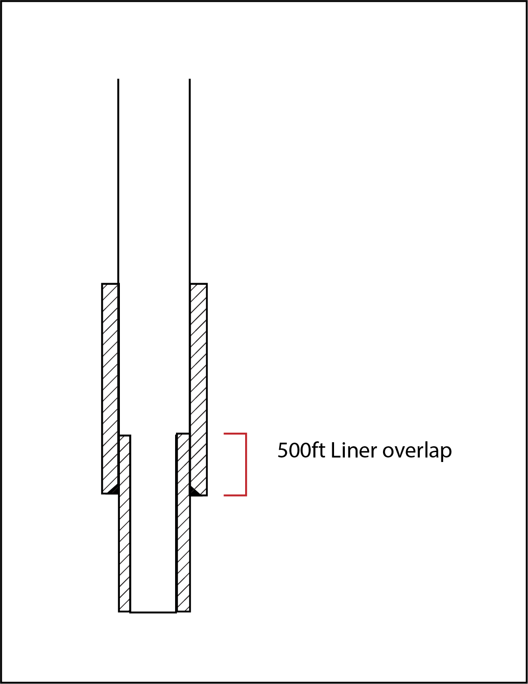

After finding the collapse pressure, burst pressure and the tensile load at each casing seating depth, we were able to determine the grade of the pipe by comparing the calculated values to the manufacturer values of each grades of pipe at the various chosen outer diameter. The production casing will be an N-80 liner casing, then casing string 4 is Q-125, casing string 3 is C-90, casing string 2 is N-80, casing string 1 is M-65, surface casing is also M-65 and the conductor casing is an STD pipe that will essentially be pounded in to the seafloor. The table 4 below also shows the calculated collapse pressure, burst pressure and tensile loading. Table 5 shows the catalogue values of collapse pressure, burst pressure and tensile loading as well as the weight and grade of casing at each depth.

Table 4: Calculated values for collapse, and burst pressure and tensile loading

|  |  |  |  |  |  |
| --- | --- | --- | --- | --- | --- |
| **Casing String No.** | **Calc. Pc (Psi)** | **Calc.P burst(bottom) (Psi)** | **Calc. P burst (top) (Psi)** | **Final Burst with Liners (Psi)** | **Tensile loading (lbs.)** |
|
| Production Casing String 5 | 6230.931 | 6250.170 | 7220.480 | 7220.480 | 400200.174 |
| Casing String 4 | 4888.330 | 5497.834 | 8978.813 | 10980.423 | 1043249.679 |
| Casing String 3 | 3430.470 | 3650.026 | 6606.434 | 6606.434 | 1289925.000 |
| Casing String 2 | 2454.041 | 2648.745 | 4816.776 | 4816.776 | 1103601.883 |
| Casing String 1 | 1639.794 | 1750.302 | 2326.425 | 2326.425 | 350551.476 |
| Surface Casing | 583.027 | 934.959 | 1934.784 | 2740.988 | 714186.621 |
| Conductor Casing |  |  |  |  | 200303.384 |
|  |  |  |  | 0.000 |

Table 5: Catalogue values of collapse, burst pressure and tensile loading, and grade of pipe (Tenaris, n.d.)

|  |  |  |  |  |  |
| --- | --- | --- | --- | --- | --- |
| **Casing String No.** | **Pipe Weight (ppf)** | **Casing Grade** | **Collapse Resistance Pc (psi)** | **Internal Yield Pressure Pb (Pi) (psi)** | **Body Pipe Yield Tensile Load (lbs)** |
|
| Production Casing String 5 | 29 | N-80 | 7020 | 8160 | 676000 |
| Casing String 4 | 53.5 | Q-125 | 8440 | 12390 | 1943000 |
| Casing String 3 | 88.2 | C-90 | 4130 | 7220 | 2297000 |
| Casing String 2 | 102.9 | N-80 | 2770 | 5470 | 2415000 |
| Casing String 1 | 123 | M-65 | 1800 | 3820 | 2297000 |
| Surface Casing | 146.500 | M-65 | 1140 | 3230.000 | 2728000 |
| Conductor Casing | 102.72 | STD |  |  |  |
|  |  |  |  |

**Conclusion/Future Work**

Drilling in an unconsolidated sandstone formation in Gulf of Mexico can be quiet challenging, therefore some of the key aspects of drilling plan were discussed such as the well plan, rig selection, mud window and the pipe program. Based on the mud frac weight and pore mud weight, we were able to determine that we need 7 casing strings and from the pressures we established the depths of the casing strings. Using collapse pressure, burst pressure and tensile load equations, we also estimated the grade of casing type at each depth. The final report of this project will further discuss the directional drilling plan, the installation of BOP’s as well as the well economics and methods that will enhance the flow rate of this well while also maintaining the pressure.

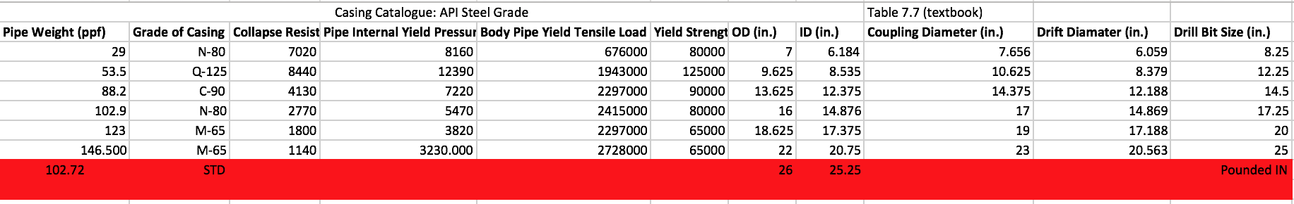

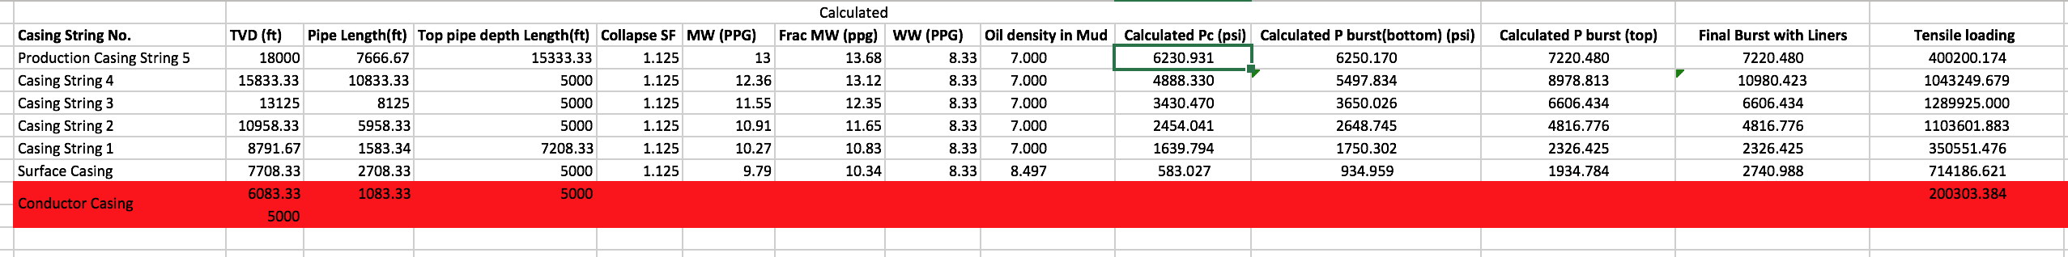

Pipe Program Calculations

References

Adams B. T., Keith, K. M., Martin, C. E., et al., 1986, Applied Drilling Engineering, Richardson, TX, The Society of Petroleum Engineers.

Bommer, P. (2017). *Casing Design*. Lecture presented at UT Austin, Austin, TX.

Bommer, P. (2017). *Wellbore Architecture*. Lecture presented at UT Austin, Austin, TX.

Galloway, W., (2009). Gulf of Mexico., Institute of Geophysics, The University of Texas at Austin, GeoExPro, Retrieved October 15, 2017, from https://www.geoexpro.com/articles/2009/03/gulf-of-mexico

Newtas Group Oil, (2017), Rig Sizing and Selection, Retrieved October 2, 2017, from https://www.netwasgroup.us/engineering-2/rig-sizing-and-selection-1.html

Tenaris, (n.d), Tenaris Casing Catalogue, Retrieved October 15, 2017, from https://utexas.instructure.com/courses/1207106/files/?preview=43155950

Transocean, (2017), Transocean 706, Retrieved October 10, 2017, from http://www.deepwater.com/Documents/RigSpecs/Transocean%20706.pdf

# Varel Oil and Gas, (2016), Look at that bit! It is so BIG!, Retrieved October 10, 2017, from

http://www.vareloilandgas.com/index.php/en/blog/look-at-that-bit-it-is-so-big